A chronology of key events:

1906 - Muslim League founded as forum for Indian Muslim separatism.

1940 - Muslim League endorses idea of separate state for India's Muslims.

1947 - Muslim state of East and West Pakistan created out of partition of India at the end of British rule. Hundreds of thousands die in widespread communal violence, and millions are made homeless.

1948 - Muhammed Ali Jinnah, founding leader of Pakistan, dies. First war with India over disputed territory of Kashmir.

## **Military rule**

1951 - Jinnah's successor Liaquat Ali Khan is assassinated.

1956 - Constitution proclaims Pakistan an Islamic republic.

1958 - Martial law declared and General Ayyub Khan takes over.

## **War and secession**

1965 - Second war with India over Kashmir.

1969 - General Ayyub Khan resigns and General Yahya Khan takes over.

1970 - Victory in East Pakistan election for breakaway Awami League, leading to rising tension with West Pakistan.

1971 - East Pakistan attempts to secede, leading to civil war. India intervenes in support of East Pakistan, which eventually breaks away to become Bangladesh.

1972 - Simla peace agreement with India sets new frontline in Kashmir.

1973 - Populist Zulfiqar Ali Bhutto becomes prime minister.

## **Zia takes charge**

1977 - Riots erupt over allegations of vote-rigging by Zulfiqar Ali Bhutto's Pakistan People's Party (PPP). General Zia ul-Haq launches military coup.

1978 - General Zia becomes president, ushers in Islamic legal system.

1979 - Zulfiqar Ali Bhutto hanged amid international protests.

1980 - US pledges military assistance to Pakistan following Soviet intervention in Afghanistan.

1985 - Martial law and political parties ban lifted.

1986 - Zulfiqar Ali Bhutto's daughter Benazir returns from exile to lead PPP in campaign for fresh elections.

1988 August - General Zia, US ambassador, and top army brass die in air crash.

## **Bhutto comeback**

1988 November - Benazir Bhutto's PPP wins general election.

1990 - Benazir Bhutto dismissed as prime minister on charges of incompetence and corruption.

1991 - Conservative Prime Minister Nawaz Sharif begins economic liberalisation programme. Islamic Sharia law formally incorporated into legal code.

1992 - Government launches campaign to stamp out violence by Urdu-speaking supporters of the Mohajir Quami Movement.

1993 - Prime Minister Sharif resigns under pressure from military. General election brings Benazir Bhutto back to power.

## **Nuclear tests**

1996 - President Leghari dismisses Bhutto government amid corruption allegations.

1997 - Nawaz Sharif returns as prime minister after Muslim League wins elections.

1998 - Pakistan conducts its own nuclear tests after India explodes several nuclear devices.

1999 April - Benazir Bhutto and husband convicted of corruption and given jail sentences. Ms Bhutto stays out of the country.

1999 May - Kargil conflict: Pakistan-backed forces clash with the Indian military in the icy heights around Kargil in Indian-held Kashmir. More than 1,000 people are killed on both sides.

Musharraf coup

1999 October - General Pervez Musharraf seizes power in coup.

2000 April - Nawaz Sharif sentenced to life imprisonment on hijacking and terrorism charges over his actions to prevent the 1999 coup. Goes into exile in Saudi Arabia later in the year after being pardoned by military authorities.

2001 June - Gen Musharraf names himself president while remaining head of the army.

2001 September - President Musharraf backs the US in its fight against terrorism and supports attacks on the Taliban and al-Qaeda in Afghanistan. US lifts some sanctions imposed after Pakistan's nuclear tests in 1998.

2002 January - President Musharraf bans two militant groups - Lashkar-e-Toiba and Jaish-e-Mohammad - and takes steps to curb religious extremism.

2002 April - President Musharraf wins another five years in office in a controversial referendum.

## **Thaw with India**

2003 November - Pakistan declares a Kashmir ceasefire; India follows suit.

2003 December - Pakistan and India agree to resume direct air links and to allow overflights of each other's planes from beginning of 2004, after a two-year ban.

2004 February - Nuclear scientist Abdul Qadeer Khan admits to having leaked nuclear weapons secrets, reportedly to Libya, North Korea and Iran.

2004 June - Pakistan mounts first military offensive against suspected al-Qaeda militants and their supporters in tribal areas near Afghan border. US begins using drone strikes to target al-Qaeda leaders in the area.

2004 April - Parliament approves creation of military-led National Security Council, institutionalising role of armed forces in civilian affairs.

2005 April - Bus services, the first in 60 years, operate between Muzaffarabad in Pakistani-administered Kashmir and Srinagar in Indian-controlled Kashmir.

2005 August - Pakistan tests its first nuclear-capable cruise missile.

## **Kashmir quake**

2005 October - Earthquake kills tens of thousands of people in Pakistani-administered Kashmir.

2007 February - Pakistan and India sign an agreement aimed at reducing the risk of accidental nuclear war.

## **Musharraf targets judiciary**

2007 March - President Musharraf suspends Chief Justice Iftikhar Mohammed Chaudhry, triggering a wave of protests across the country.

2007 July - Security forces storm the jihadist-occupied Red Mosque complex in Islamabad following a week-long siege.

Supreme Court reinstates Chief Justice Chaudhry.

2007 October - Ex-prime minister Benazir Bhutto returns from exile. Dozens of people die in a suicide bomb targeting her homecoming parade in Karachi.

2007 October-November - Musharraf wins presidential election but is challenged by Supreme Court. He declares emergency rule, dismisses Chief Justice Chaudhry and appoints new Supreme Court, which confirms his re-election.

2007 November - Former prime minister Nawaz Sharif returns from exile.

## **Bhutto killed, Musharraf resigns**

2007 December - Benazir Bhutto assassinated at political rally at election campaign rally in Rawalpindi.

2008 February-March - Pakistan People's Party (PPP) nominee Yusuf Raza Gilani becomes PM at head of coalition with Nawaz Sharif's Muslim League party following parliamentary elections in February.

2008 August - President Musharraf resigns after the two main governing parties agree to launch impeachment proceedings against him.

Nawaz Sharif pulls his PML-N out of the coalition, accusing the PPP of breaking its promise to reinstate all judges sacked by President Musharraf.

2008 September - MPs elect Pakistan People's Party's (PPP) Asif Ali Zardari - the widower of assassinated former PM Benazir Bhutto - president.

Suicide bombing on Marriott Hotel in Islamabad kills 53 people. Soon after, government launches major offensive in Bajaur tribal area, killing more than 1,000 militants.

2008 November - The government borrows billions of dollars from the International Monetary Fund to overcome its spiralling debt crisis.

## **Tribal areas turmoil**

2008 December - India blames Mumbai attacks in November on Pakistani-based militants, and demands Pakistan take action. Islamabad denies involvement but promises to co-operate with the Indian investigation.

2009 March - After days of protests, government yields to demands for reinstatement of judges dismissed by former President Musharraf.

2009 August - The leader of Pakistan's Taliban, Baitullah Mehsud, is killed in US drone attack in South Waziristan. He is succeeded by Hakimullah Mehsud.

Suicide bombing in northwestern city of Peshawar kills 120 people.

## **Reform efforts**

2010 April - Parliament approves package of wide-ranging constitutional reforms. Measures include transferring key powers from president to prime minister.

2010 August - Worst floods in 80 years kill at least 1,600 people and affect more than 20 million. Government response widely criticised.

2011 January - A campaign to reform Pakistan's blasphemy law leads to the killing of two prominent supporters, Punjab Governor Salman Taseer in January, and Minorities Minister Shahbaz Bhatti in March.

2011 May - The founder of al-Qaeda, Osama bin Laden, is killed by American special forces in Abbottabad.

## **"Memogate"**

2011 December - Government comes under pressure over a leaked memo alleging senior officials sought US aid against a military coup after the killing of Osama bin Laden in April.

2012 January - Amid growing tension between government and military over "memogate" scandal, army chief Gen Pervez Kayani warns of "unpredictable consequences" after PM Yousuf Raza Gilani criticises army leaders and sacks top defence official.

2012 May - A US Senate panel cuts $33m in aid to Pakistan over the jailing of Pakistani doctor Shakil Afridi who helped the CIA find Osama Bin Laden.

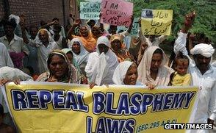

Image source,

Getty Images

Image caption,

The arrest of Rimsha, a Christian girl, prompted protests against blasphemy laws

2012 June - Supreme Court disqualifies Prime Minister Gilani from holding office after he declines to appeal against a token sentence in President Zardari corruption row. Parliament approves Water and Power Minister Raja Pervez Ashraf as his successor.

2012 July - Pakistan agrees to reopen Nato supply routes to Afghanistan after the US apologises for killing Pakistani soldiers in November.

Sunni extremist violence increases

2012 September - Muslim cleric Khalid Chishti is arrested on suspicion of planting burnt pages of the Koran on a Christian girl briefly detained for blasphemy. Amid widespread condemnation of the case against the girl at home and abroad, a court dropped it November.

2012 October - Taliban gunmen seriously injure 14-year-old campaigner for girls' rights Malala Yousafzai, whom they accused of "promoting secularism". The shooting sparked a brief upsurge of anger in Pakistan against the militants.

2012 November - Taliban suicide bomber kills at least 23 people at a Shia Muslim procession in the Rawalpindi.

2013 June - Parliament approves Nawaz Sharif as prime minister after his Muslim League-N wins parliamentary elections in May.

2014 June - A deadly assault on Karachi's international airport leaves dozens dead. Uzbek militants fighting with the Pakistani Taliban say they carried out the attack. Peace talks with the Taliban collapse and the army launches a major offensive on Islamist hideouts in north-west Pakistan.

2014 October - Teenager Malala Yousafzai, who was shot in the head by the Taliban but survived to become a campaigner for girls' education, becomes the youngest person ever to win the Nobel Peace Prize.

## **Peshawar school attack**

2014 December - Taliban kills nearly 150 people - mostly children - in an attack on a school in Peshawar.

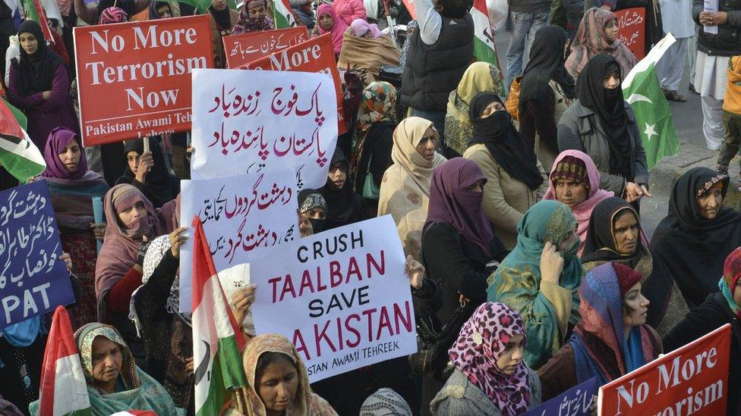

Image source,

AFP/Getty Images

Image caption,

The country saw anti-Taliban protests after the Peshawar school attack of 2014

Government responds to the massacre by lifting a moratorium on the death penalty and launching round-up of terror suspects, although critics complain major terror organisers are left alone.

2015 April - India protests over Pakistan court release on bail of suspected mastermind of 2008 Mumbai terror attacks, Zakiur Rehman Lakhvi. Human rights activist Sabeen Mehmud shot dead in Karachi.

2015 April - China and Pakistan sign agreements worth billions of dollars to boost infrastructure. They are designed to end Pakistan's chronic energy crisis and transform the country into a regional economic hub.

2015 June - Pakistan acknowledges that eight out of ten Taliban members allegedly jailed for the gun attack on teenage education activist and Nobel Prize laureate Malala Yousafzai were secretly acquitted at their trial in April.

2016 November - Gen Qamar Javed Bajwa is named as new army chief. The position is arguably the most powerful in the country.

2017 February - The Islamic State group takes responsibility for a suicide bombing at a major Sufi shrine in Sindh which killed nearly 90 people. Pakistan closes border with Afghanistan.

2017 March - Parliament passes a law allowing the country's Hindu minority to register their marriages for the first time since partition from India in 1947.

## **Rise of Imran Khan**

2017 August - Prime Minister Nawaz Sharif is forced to resign after being disqualified by the Supreme Court over corruption charges. He is convicted and given a jail sentence.

2018 August - Former international cricket star Imran Khan becomes prime minister on a pledge to end corruption and dynastic politics, after his Pakistan Tehreek-e-Insaf (PTI) becomes the largest party in the July general election.

2018 November - Asia Bibi, a Christian woman acquitted of blasphemy after eight years on death row, is freed from prison, prompting violent protests by Islamists.

2019 February - Clashes with India follow an attack by the Pakistan-based Jaish-e Mohammad jihadist group on security forces' convoy in Indian-controlled Kashmir.